Online Supplement

For

“Increased support for collective defence in times of threat:
European public opinion
before and after Russia’s invasion of Ukraine”

Content:

Online Supplement 1: Details about BLINDED surveys 2
Online Supplement 2: Additional descriptives 3
Online Supplement 3: Regression table for Figure 5 6
Online Supplement 4: Regression of aggregate collective defence attitude 7
Online Supplement 5: More restrictive models 8
Online Supplement 6: Threat * Survey dummy interactions 11

Online Supplement 1: Details about BLINDED surveys

See p.6 of the article.

Pre-invasion surveys
The reported data from the BLINDED pre-invasion surveys targeted the 18+ population in 10 European countries: Estonia, Finland, France, Germany, Hungary, Italy, Poland, Spain, Sweden, and the United Kingdom. Partner survey vendor was IPSOS. Field times of the two waves were 8 Oct 2020 – 3 Nov 2020 and 14 Jun 2021 – 16 August 2021, with target sample sizes of 2,000 for France, Germany, Italy, Poland, Spain and UK and 1,500 for Estonia, Finland, Hungary and Sweden. The sampling involved quota selection from the IPSOS Access Panel according to gender, age, region, and education.

Post-invasion survey
The BLINDED post-invasion survey targeted the 18+ populations in 10 European countries: Estonia, Finland, France, Germany, Hungary, Italy, Poland, Spain, Sweden, and the United Kingdom. Partner survey vendors were Dynata (for Estonia, Finland, Hungary, Italy, Poland, Spain and Sweden) and YouGov (for France, Germany and UK). Field times of the surveys were 03 Feb 2023 – 03 Mar 2023 (Dynata surveys) and 21 Feb 2023 – 08 Mar 2023 (YouGov surveys). Target sample sizes were 1,500 in case of France, Germany and UK and 1,000 in case of Estonia, Finland, Hungary, Italy, Poland, Spain and Sweden. The sampling involved quota selection from the Dynata Access Panel and YouGov Access Panel according to gender, age, region, and education.

Online Supplement 2: Additional descriptives

See footnotes 6, 7 and 8 of the article.

Figure S2.1. Trust in NATO
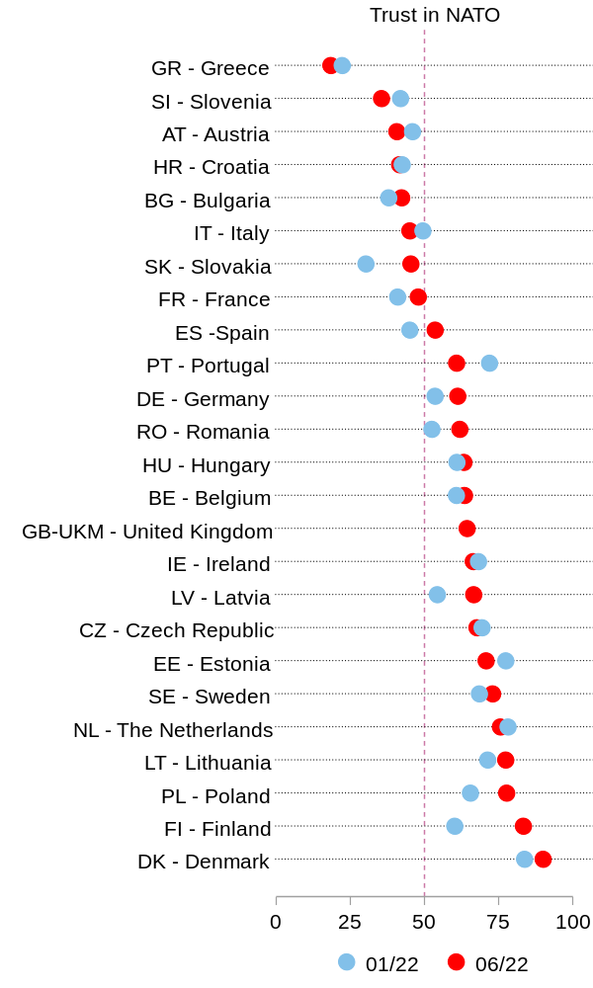
Note: Eurobarometer 96.3 and 97.5 data. Question wording: “For each of the following institutions, do you tend to trust it or tend not to trust it? – NATO”; response options: 1=“Tend to trust”, 2=“Tend not to trust”. Reported are percent of respondents who “tend to trust” NATO.

Figure S2.2. Support for EU security and defence policy
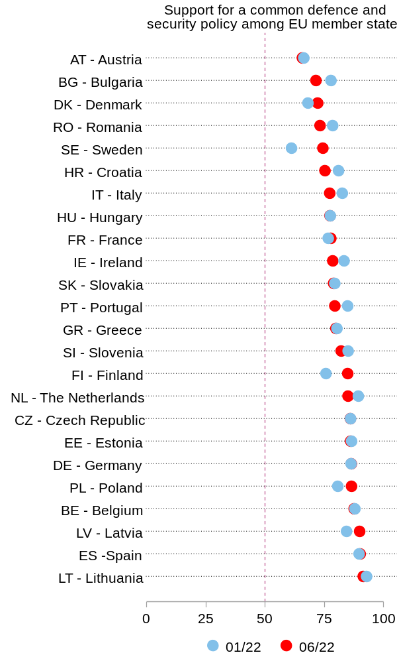
Note: Left panel: Eurobarometer 96.3 and 97.5 data. Question wording: “What is your opinion on each of the following statements? Please tell for each statement, whether you are for it or against it. – A common defence and security policy among EU Member States”; response options: 1=“For”, 2=“Against”. Reported are percent of respondents who chose option 1.

Figure S2.3. Support for EU defence activities
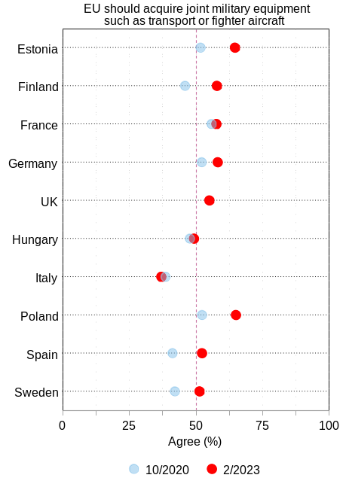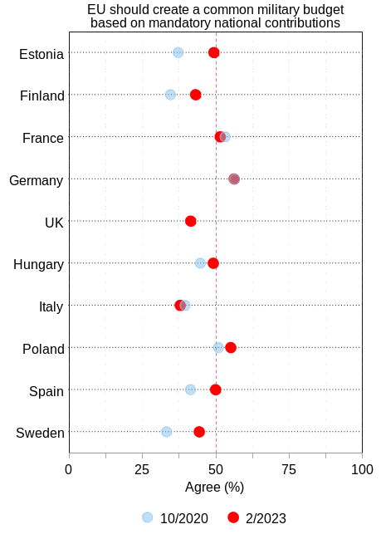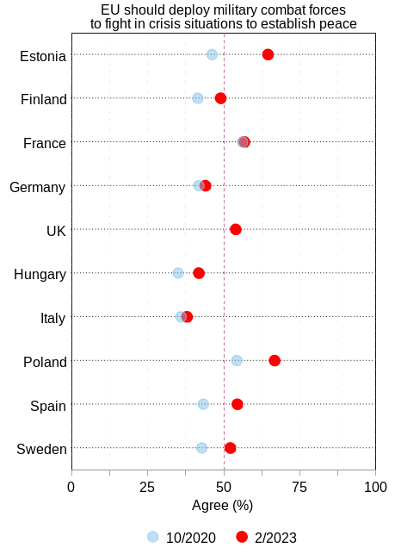
Note: BLINDED data. Question wording: [Joint intro to all items] “There are different activities that the European Union could engage in as part of its Common Security and Defence Policy. Would you approve or disapprove of the European Union engaging in the following activities:”; Left panel: “– Acquiring joint military equipment such as transport or fighter aircraft.”; Left panel: “– Acquiring joint military equipment such as transport or fighter aircraft.”; Middle panel: “– Creating a common military budget based on mandatory national contributions.” Right panel: “– Deploying military combat forces to fight in crisis situations to establish peace.” Response options: 1=“Strongly approve”… 7=”Strongly disapprove”. Reported are percent of respondents who chose options 5, 6, or 7.

Online Supplement 3: Regression table for Figure 5

See footnote 11 of the article.

Table S3.1. Full regression results
 | DV: Military alliances should be essential |  | DV: Willingness to use military force to defend ally (Latvia) |  | CV: NATO is an essential part of COUNTRY's national security
 | 10/2020 | 2/2023 | 10/2020 | 2/2023 | 10/2020 | 2/2023
Threat perception | 0.39*** | 0.44*** | 0.39*** | 0.51*** | 0.38*** | 0.49***
 | (0.02) | (0.04) | (0.03) | (0.04) | (0.02) | (0.04)
Finland * Threat | -0.16*** | -0.19*** | -0.18*** | -0.27*** | -0.04
 | (0.04) | (0.05) | (0.04) | (0.06) | (0.04)
France * Threat | -0.30*** | -0.18*** | -0.14*** | -0.16** | -0.21*** | -0.18***
 | (0.04) | (0.04) | (0.04) | (0.05) | (0.04) | (0.05)
Germany * Threat | -0.25*** | -0.15*** | -0.20*** | -0.18*** | -0.20*** | -0.14***
 | (0.03) | (0.04) | (0.04) | (0.05) | (0.03) | (0.04)
UK * Threat | -0.23*** | -0.25*** | -0.18*** | -0.22*** | -0.23*** | -0.27***
 | (0.03) | (0.05) | (0.04) | (0.06) | (0.03) | (0.05)
Hungary * Threat | -0.32*** | -0.31*** | -0.30*** | -0.30*** | -0.29*** | -0.38***
 | (0.03) | (0.04) | (0.04) | (0.05) | (0.03) | (0.05)
Italy * Threat | -0.33*** | -0.16*** | -0.23*** | -0.20*** | -0.27*** | -0.11*
 | (0.03) | (0.05) | (0.04) | (0.06) | (0.03) | (0.05)
Poland * Threat | -0.28*** | -0.24*** | -0.24*** | -0.30*** | -0.27*** | -0.24***
 | (0.03) | (0.05) | (0.04) | (0.06) | (0.03) | (0.05)
Spain * Threat | -0.28*** | -0.23*** | -0.30*** | -0.29*** | -0.28*** | -0.21***
 | (0.03) | (0.05) | (0.04) | (0.06) | (0.03) | (0.05)
Sweden * Threat | -0.12*** | -0.16*** | -0.14*** | -0.18** | -0.06
 | (0.03) | (0.05) | (0.04) | (0.06) | (0.04)
Finland | -0.09*** | 0.10** | -0.11*** | 0.11* | -0.30***
 | (0.02) | (0.04) | (0.03) | (0.05) | (0.02)
France | 0.11*** | 0.03 | -0.09*** | 0.01 | -0.09*** | -0.04
 | (0.02) | (0.04) | (0.03) | (0.04) | (0.02) | (0.04)
Germany | 0.09*** | 0.06 | -0.10*** | 0.01 | -0.01 | 0.05
 | (0.02) | (0.03) | (0.02) | (0.04) | (0.02) | (0.03)
UK | 0.12*** | 0.17*** | -0.05 | 0.06 | 0.09*** | 0.19***
 | (0.02) | (0.04) | (0.03) | (0.05) | (0.02) | (0.04)
Hungary | 0.16*** | 0.17*** | -0.11*** | -0.06 | 0.08*** | 0.22***
 | (0.02) | (0.04) | (0.03) | (0.04) | (0.02) | (0.04)
Italy | 0.09*** | -0.00 | -0.09*** | -0.10* | 0.03 | -0.07
 | (0.02) | (0.04) | (0.03) | (0.05) | (0.02) | (0.04)
Poland | 0.17*** | 0.19*** | 0.08** | 0.24*** | 0.13*** | 0.19***
 | (0.02) | (0.04) | (0.03) | (0.05) | (0.02) | (0.04)
Spain | 0.08*** | 0.09* | -0.03 | 0.10* | 0.04* | 0.05
 | (0.02) | (0.04) | (0.03) | (0.05) | (0.02) | (0.04)
Sweden | -0.10*** | 0.01 | -0.10*** | 0.04 | -0.26***
 | (0.02) | (0.04) | (0.03) | (0.05) | (0.03)
Age | 0.00*** | 0.00*** | -0.00*** | -0.00** | 0.00*** | 0.00***
 | (0.00) | (0.00) | (0.00) | (0.00) | (0.00) | (0.00)
Gender (1=female) | -0.04*** | -0.05*** | -0.01* | -0.04*** | -0.03*** | -0.04***
 | (0.00) | (0.00) | (0.00) | (0.01) | (0.00) | (0.00)
Education (medium) | -0.00 | 0.01 | -0.02* | 0.00 | 0.01 | 0.01
 | (0.01) | (0.01) | (0.01) | (0.01) | (0.01) | (0.01)
Education (high) | 0.00 | 0.03*** | 0.01 | 0.02* | 0.03*** | 0.03***
 | (0.01) | (0.01) | (0.01) | (0.01) | (0.01) | (0.01)
L-R self-placement | 0.16*** | 0.04*** | 0.08*** | -0.01 | 0.11*** | 0.00
 | (0.01) | (0.01) | (0.01) | (0.01) | (0.01) | (0.01)
Constant | 0.36*** | 0.31*** | 0.46*** | 0.35*** | 0.46*** | 0.31***
 | (0.02) | (0.03) | (0.02) | (0.04) | (0.02) | (0.03)
N | 13697 | 10530 | 13562 | 10268 | 13543 | 10463
adj. R² | 0.136 | 0.148 | 0.136 | 0.160 | 0.193 | 0.175
Estonia is reference category for country dummies, Low education is reference category for education dummies; * p < 0.05, ** p < 0.01, *** p < 0.001

Online Supplement 4: Regression of aggregate collective defence attitude

See footnote 12 of the article.

Table S4.1: Exploratory factor analysis of collective defence attitudes
 | Pre-invasion (10/2020) | Post-invasion (2/2023)
 | F1 | F1
Alliances essential part of COUIINTRY’s security strategy | .62 | .69
Willingness to deploy troops to secure Latvian border | .40 | .54
NATO is an essential part of COUNTRY’s national security | .63 | .70
Note: Reported are factor loadings from an exploratory factor analysis (promax rotation) that did not constrain the number of factors to be extracted.

Summative indexes were calculated from the responses to the three collective defence. This aggregation methods retains the original theoretical range of the variables, increasing interpretability, and allows easier comparison with Figure 5.

Figure S4.1: Effects of threat perceptions on collective defence attitudes (summative index)
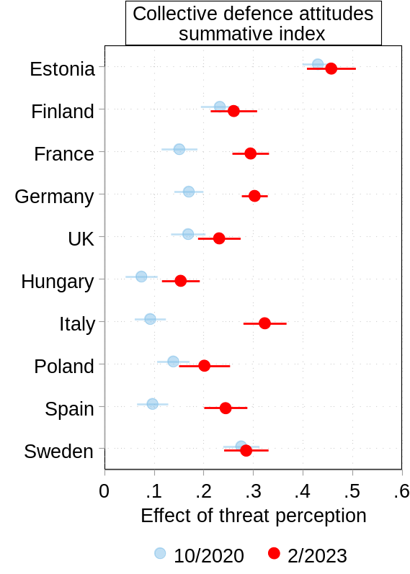
No data
No data
Note: BLINDED data. Reported are unstandardized OLS coefficients with 95% confidence intervals. All variables have a range of 0–1.

Online Supplement 5: More restrictive models

See p.18 of the article.

The restrictive models introduce three additional control variables: Attitudes towards the European Union, posture towards use of military force, posture towards international (non-)involvement. The following items were used to measure them. In case of the postures, additive indexes were computed.

Attitudes towards the European Union
[Question:] Next you will see a series of people, countries and groups. We'd like to know how you feel about each person or group. Please use the following scales from 0 to 10, where 0 represents feeling very coldly towards that person or group and 10 represents feeling very warmly towards that person or group.
– The European Union
[Coding:]: 0 – Very coldly … 10 – Very warmly

Posture towards use of military force
[Question:] Please say whether you agree or disagree with each of the following statements:
– COUNTRY needs a strong military to be effective in international affairs.
– COUNTRY should take all steps including the use of force to prevent aggression by any expansionist power.
– COUNTRY should be more committed to diplomacy and avoid the use of military force in international crises. [Reversed]
– Building strength and showing resolve are the best ways for COUNTRY to protect its interests.
[Coding:] 1 – Strongly disagree … 5 – Strongly agree

Posture towards international (non-)involvement
[Question:] Please say whether you agree or disagree with each of the following statements:
– COUNTRY’s interests are best protected by avoiding any involvement with other nations.
– COUNTRY shouldn't risk its citizens' happiness and wellbeing by getting involved with other nations.
– COUNTRY should withdraw from international affairs and simply mind its own business.
[Coding:] 1 – Strongly disagree … 5 – Strongly agree

Figure S5.1: Effect of threat perception on attitudes twd collective defence (with add. controls)
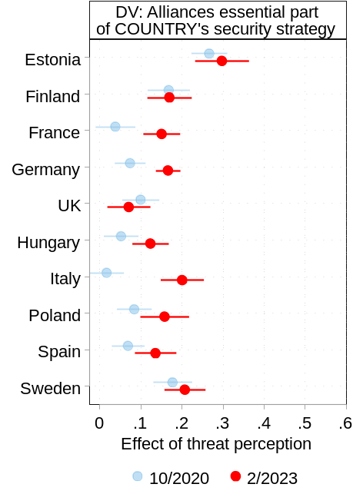 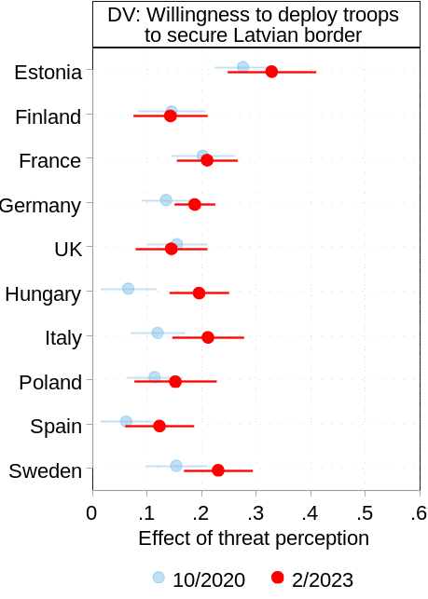 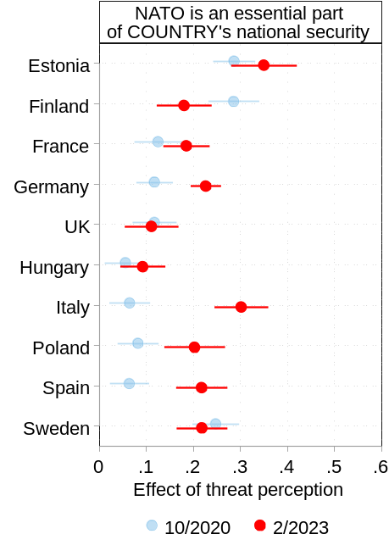 Note: BLINDED data. Reported are unstandardized OLS coefficients with 95% confidence intervals. All variables have a range of 0–1.
No data
No data

Regressions of militant internationalism posture on populism and other predictors
 | DV: Military alliances should be essential |  | DV: Willingness to use military force to defend ally (Latvia) |  | CV: NATO is an essential part of COUNTRY's national security
 | 10/2020 | 2/2023 | 10/2020 | 10/2020 | 2/2023 | 10/2020
Threat perception | 0.27*** | 0.30*** | 0.28*** | 0.33*** | 0.29*** | 0.35***
 | (0.02) | (0.03) | (0.03) | (0.04)
Finland * Threat | -0.10** | -0.13** | -0.13** | -0.19***
 | (0.03) | (0.04) | (0.04) | (0.05) | (0.04) | (0.05)
France * Threat | -0.23*** | -0.15*** | -0.07 | -0.12* | -0.16*** | -0.16***
 | (0.03) | (0.04) | (0.04) | (0.05) | (0.03) | (0.04)
Germany * Threat | -0.19*** | -0.13*** | -0.14*** | -0.14** | -0.17*** | -0.12**
 | (0.03) | (0.04) | (0.04) | (0.05) | (0.03) | (0.04)
UK * Threat | -0.17*** | -0.23*** | -0.12** | -0.18*** | -0.17*** | -0.24***
 | (0.03) | (0.04) | (0.04) | (0.05) | (0.03) | (0.05)
Hungary * Threat | -0.21*** | -0.17*** | -0.21*** | -0.13** | -0.23*** | -0.26***
 | (0.03) | (0.04) | (0.04) | (0.05) | (0.03) | (0.04)
Italy * Threat | -0.25*** | -0.10* | -0.16*** | -0.12* | -0.22*** | -0.05
 | (0.03) | (0.04) | (0.04) | (0.05) | (0.03) | (0.05)
Poland * Threat | -0.18*** | -0.14** | -0.16*** | -0.18** | -0.20*** | -0.15**
 | (0.03) | (0.04) | (0.04) | (0.06) | (0.03) | (0.05)
Spain * Threat | -0.20*** | -0.16*** | -0.21*** | -0.21*** | -0.22*** | -0.13**
 | (0.03) | (0.04) | (0.04) | (0.05) | (0.03) | (0.04)
Sweden * Threat | -0.09** | -0.09* | -0.12** | -0.10
 | (0.03) | (0.04) | (0.04) | (0.05)
Finland | -0.14*** | 0.04 | -0.16*** | 0.03
 | (0.02) | (0.04) | (0.03) | (0.04)
France | 0.02 | -0.09* | -0.17*** | -0.09* | -0.12*** | -0.15***
 | (0.02) | (0.03) | (0.03) | (0.04) | (0.02) | (0.04)
Germany | 0.06*** | 0.01 | -0.12*** | -0.03 | -0.02 | -0.00
 | (0.02) | (0.03) | (0.02) | (0.04) | (0.02) | (0.03)
UK | 0.07** | 0.05 | -0.09*** | -0.06 | 0.07** | 0.06
 | (0.02) | (0.04) | (0.03) | (0.04) | (0.02) | (0.04)
Hungary | 0.12*** | 0.10** | -0.15*** | -0.15*** | 0.06** | 0.15***
 | (0.02) | (0.03) | (0.02) | (0.04) | (0.02) | (0.03)
Italy | 0.05** | -0.01 | -0.12*** | -0.10* | 0.02 | -0.08*
 | (0.02) | (0.04) | (0.03) | (0.04) | (0.02) | (0.04)
Poland | 0.10*** | 0.12** | 0.02 | 0.16** | 0.09*** | 0.13**
 | (0.02) | (0.04) | (0.03) | (0.05) | (0.02) | (0.04)
Spain | 0.03 | 0.03 | -0.07** | 0.04 | 0.02 | -0.01
 | (0.02) | (0.04) | (0.02) | (0.04) | (0.02) | (0.04)
Sweden | -0.13*** | -0.04 | -0.12*** | -0.00
 | (0.02) | (0.04) | (0.03) | (0.04)
Age | 0.00*** | 0.00*** | -0.00*** | -0.00*** | 0.00*** | 0.00***
 | (0.00) | (0.00) | (0.00) | (0.00) | (0.00) | (0.00)
Gender (1=female) | -0.03*** | -0.04*** | -0.00 | -0.03*** | -0.02*** | -0.03***
 | (0.00) | (0.00) | (0.00) | (0.01) | (0.00) | (0.00)
Education (medium) | 0.00 | 0.00 | -0.02* | -0.01 | 0.00 | 0.00
 | (0.01) | (0.01) | (0.01) | (0.01) | (0.01) | (0.01)
Education (high) | -0.00 | 0.02*** | 0.01 | 0.00 | 0.01* | 0.02*
 | (0.01) | (0.01) | (0.01) | (0.01) | (0.01) | (0.01)
Left-right self-placement | 0.11*** | 0.01 | 0.03*** | -0.03* | 0.12*** | -0.01
 | (0.01) | (0.01) | (0.01) | (0.01) | (0.01) | (0.01)
MI index | 0.45*** | 0.55*** | 0.41*** | 0.57*** | 0.23*** | 0.45***
 | (0.01) | (0.01) | (0.01) | (0.02) | (0.01) | (0.02)
ISO index | -0.04*** | -0.13*** | -0.06*** | -0.23*** | -0.07*** | -0.15***
 | (0.01) | (0.01) | (0.01) | (0.01) | (0.01) | (0.01)
Attitude twd EU | 0.16*** | 0.02*** | 0.15*** | 0.02*** | 0.22*** | 0.02***
 | (0.01) | (0.00) | (0.01) | (0.00) | (0.01) | (0.00)
Constant | 0.15*** | 0.20*** | 0.29*** | 0.30*** | 0.29*** | 0.25***
 | (0.02) | (0.03) | (0.02) | (0.04) | (0.02) | (0.03)
N | 13593 | 10423 | 13435 | 10168 | 13412 | 10356
adj. R² | 0.238 | 0.279 | 0.200 | 0.265 | 0.253 | 0.268
Estonia is reference category for country dummies, Low education is reference category for education dummies
* p < 0.05, ** p < 0.01, *** p < 0.001

Online Supplement 6: Threat * Survey dummy interactions

See footnote 13 of the article.

Table S6.1: Military alliances should be essential; by country
 | EST | FIN | FRA | GER | UK | HUN | ITA | POL | SPA | SWE
Threat perception | .41*** | .24*** | .09*** | .15*** | .17*** | .05* | .06* | .12*** | .10*** | .26***
 | (.02) | (.03) | (.02) | (.02) | (.02) | (.02) | (.02) | (.02) | (.02) | (.03)
Post-invasion data | -.05 | .13*** | -.13*** | -.08*** | .01 | -.04 | -.15*** | -.02 | -.06* | .05
 | (.03) | (.03) | (.03) | (.02) | (.03) | (.02) | (.03) | (.03) | (.03) | (.03)
Threat * Post-invasion data | .04 | .03 | .18*** | .15*** | .03 | .07* | .24*** | .08* | .13*** | .01
 | (.04) | (.04) | (.03) | (.03) | (.03) | (.03) | (.04) | (.03) | (.04) | (.04)
Age | .00*** | -.00 | .00 | .00*** | .00*** | .00*** | .00 | .00*** | .00*** | .00*
 | (.00) | (.00) | (.00) | (.00) | (.00) | (.00) | (.00) | (.00) | (.00) | (.00)
Gender (1=female) | -.05*** | -.04** | -.03** | -.06*** | -.05*** | -.06*** | -.05*** | -.05*** | -.04*** | -.02
 | (.01) | (.01) | (.01) | (.01) | (.01) | (.01) | (.01) | (.01) | (.01) | (.01)
Education (medium) | .02 | .02 | -.01 | .01 | .01 | -.01 | .00 | .01 | -.02 | -.01
 | (.03) | (.02) | (.01) | (.01) | (.01) | (.02) | (.01) | (.02) | (.01) | (.02)
Education (high) | .04 | .04 | -.03* | .03* | .04*** | .03 | -.01 | .02 | -.01 | -.01
 | (.03) | (.02) | (.01) | (.01) | (.01) | (.03) | (.01) | (.02) | (.01) | (.02)
Left-right self-placement | .04 | .13*** | .08*** | .12*** | .08*** | -.08*** | .13*** | .01 | .24*** | .29***
 | (.02) | (.02) | (.02) | (.02) | (.02) | (.02) | (.02) | (.01) | (.02) | (.02)
Constant | .38*** | .30*** | .54*** | .39*** | .48*** | .59*** | .49*** | .53*** | .38*** | .18***
 | (.03) | (.03) | (.03) | (.02) | (.02) | (.03) | (.03) | (.02) | (.02) | (.04)
N | 1900 | 1961 | 2566 | 3798 | 2608 | 1980 | 2340 | 2495 | 2455 | 2124
adj. R² | .274 | .183 | .070 | .126 | .084 | .063 | .074 | .094 | .124 | .183
* p < 0.05, ** p < 0.01, *** p < 0.001

Table S6.2: DV: Willingness to use military force to defend Latvia; regressions by country
 | EST | FIN | FRA | GER | UK | HUN | ITA | POL | SPA | SWE
Threat perception | .40*** | .21*** | .25*** | .20*** | .22*** | .06* | .16*** | .14*** | .08*** | .24***
 | (.03) | (.03) | (.03) | (.03) | (.03) | (.03) | (.03) | (.03) | (.02) | (.03)
Post-invasion data | -.03 | .16*** | .06 | .05* | .05 | -.01 | -.06 | .10** | .06 | .09**
 | (.04) | (.03) | (.03) | (.02) | (.03) | (.03) | (.03) | (.04) | (.03) | (.04)
Threat * Post-invasion data | .08 | .03 | .11* | .15*** | .11* | .13** | .16*** | .06 | .14*** | .09*
 | (.05) | (.05) | (.04) | (.03) | (.05) | (.04) | (.04) | (.04) | (.04) | (.05)
Age | .00 | -.00*** | -.00*** | -.00*** | -.00*** | -.00*** | -.00*** | .00 | -.00* | -.00***
 | (.00) | (.00) | (.00) | (.00) | (.00) | (.00) | (.00) | (.00) | (.00) | (.00)
Gender (1=female) | -.02 | -.00 | -.03* | -.04*** | -.05*** | .01 | -.00 | -.05*** | -.02 | -.03**
 | (.01) | (.01) | (.01) | (.01) | (.01) | (.01) | (.01) | (.01) | (.01) | (.01)
Education (medium) | .10** | -.03 | .02 | -.00 | .00 | -.10*** | -.03* | -.02 | -.03 | .03
 | (.03) | (.02) | (.02) | (.01) | (.02) | (.03) | (.01) | (.02) | (.01) | (.02)
Education (high) | .12*** | -.00 | .03* | .02 | .03 | -.10** | -.02 | -.00 | -.00 | .03
 | (.03) | (.02) | (.02) | (.02) | (.01) | (.03) | (.02) | (.02) | (.01) | (.02)
Left-right self-placement | -.02 | .06* | -.02 | .03 | .07** | -.09*** | .08*** | .03 | .15*** | .09***
 | (.03) | (.02) | (.02) | (.03) | (.02) | (.03) | (.02) | (.02) | (.02) | (.02)
Constant | .25*** | .34*** | .36*** | .36*** | .43*** | .61*** | .38*** | .45*** | .34*** | .27***
 | (.04) | (.04) | (.03) | (.03) | (.03) | (.04) | (.03) | (.03) | (.03) | (.04)
N | 1858 | 1925 | 2563 | 3751 | 2561 | 1975 | 2319 | 2399 | 2401 | 2078
adj. R² | .203 | .167 | .134 | .144 | .110 | .088 | .107 | .121 | .132 | .162
* p < 0.05, ** p < 0.01, *** p < 0.001

Table S6.3: DV: NATO is an essential part of COUNTRY's national security; by country
 | EST | FIN | FRA | GER | UK | HUN | ITA | POL | SPA | SWE
Threat perception | .39*** |  | .17*** | .18*** | .16*** | .07** | .10*** | .11*** | .09***
 | (.02) |  | (.03) | (.02) | (.02) | (.02) | (.02) | (.02) | (.02)
Post-invasion data | -.17*** |  | -.12*** | -.10*** | -.06* | -.04 | -.27*** | -.10*** | -.18***
 | (.03) |  | (.03) | (.02) | (.03) | (.02) | (.03) | (.03) | (.03)
Threat * Post-invasion data | .10** |  | .15*** | .16*** | .06 | .02 | .28*** | .13*** | .20***
 | (.04) |  | (.04) | (.03) | (.03) | (.03) | (.04) | (.03) | (.04)
Age | .00** |  | -.00 | .00*** | .00*** | .00*** | .00 | .00*** | .00***
 | (.00) |  | (.00) | (.00) | (.00) | (.00) | (.00) | (.00) | (.00)
Gender (1=female) | -.02* |  | .03** | -.04*** | -.04*** | -.08*** | -.03** | -.06*** | -.02
 | (.01) |  | (.01) | (.01) | (.01) | (.01) | (.01) | (.01) | (.01)
Education (medium) | .06* |  | -.01 | .03* | .02* | -.03 | -.01 | .01 | .01
 | (.03) |  | (.01) | (.01) | (.01) | (.03) | (.01) | (.02) | (.01)
Education (high) | .10*** |  | -.01 | .05*** | .06*** | .02 | -.01 | .04* | -.01
 | (.03) |  | (.01) | (.01) | (.01) | (.03) | (.01) | (.02) | (.01)
Left-right self-placement | .01 |  | .03 | -.01 | .00 | -.08*** | -.01 | -.01 | .16***
 | (.02) |  | (.02) | (.02) | (.02) | (.02) | (.02) | (.01) | (.02)
Constant | .45*** |  | .48*** | .45*** | .54*** | .60*** | .59*** | .59*** | .45***
 | (.03) |  | (.03) | (.02) | (.02) | (.04) | (.03) | (.02) | (.02)
N | 1921 |  | 2475 | 3810 | 2596 | 1942 | 2345 | 2506 | 2418
adj. R² | .261 |  | .073 | .129 | .081 | .082 | .074 | .101 | .089
* p < 0.05, ** p < 0.01, *** p < 0.001

